GARGŽDAI NURSERY SCHOOL „SAULUTE“

GOOD EXPERIENCE SHARING COPING WITH STRESS AT THE COVID-19 PANDEMIC

Due to world COVID-19 pandemy and confirmed quarantine in Lithuania, stopped education in nursery schools. We discussed with parents and consulted them, to start remote education. Its necessary to educate and not forget to develop competencies as health, recohnition and artistic competencies as well.
Gargzdai nursery school „Saulute“ in remote education motivates our children not to forget how important is physical education, healthy nutrition, knowledge of the environment and other important competencies and activities important for children.
While organizing remote educating teachers used modern technologies with those teachers every day prepare for preschools tasks according week activity plan and themes and attractively introduce them to children. For example with padlet.com prepared tasks, and musical teacher prepared tasks with read.bookcreator.com. To celebrate World Health day on 7th of April, we uploaded video about physical education at home in channel Youtube.com (https://www.youtube.com/watch?v=oftKnswzjs0&t=48s) and prepared educational tasks about physical activity for all group ages. Every day teachers were sending for children musical links with gym videos for the good start of the day. For smallest teachers made colorful and graphic material about health in PDF. Because they requiremore clear, understandable and informative.
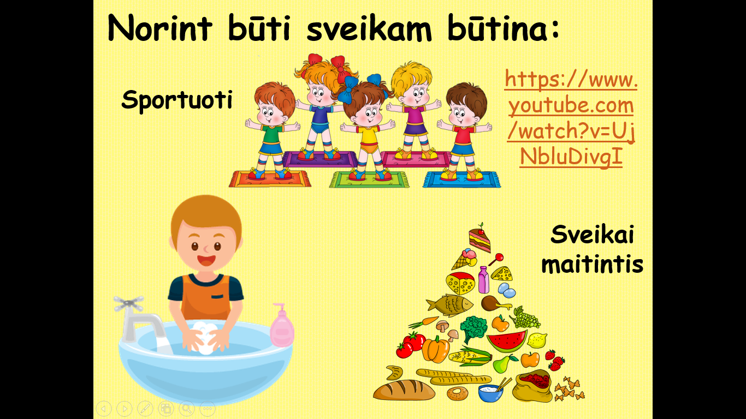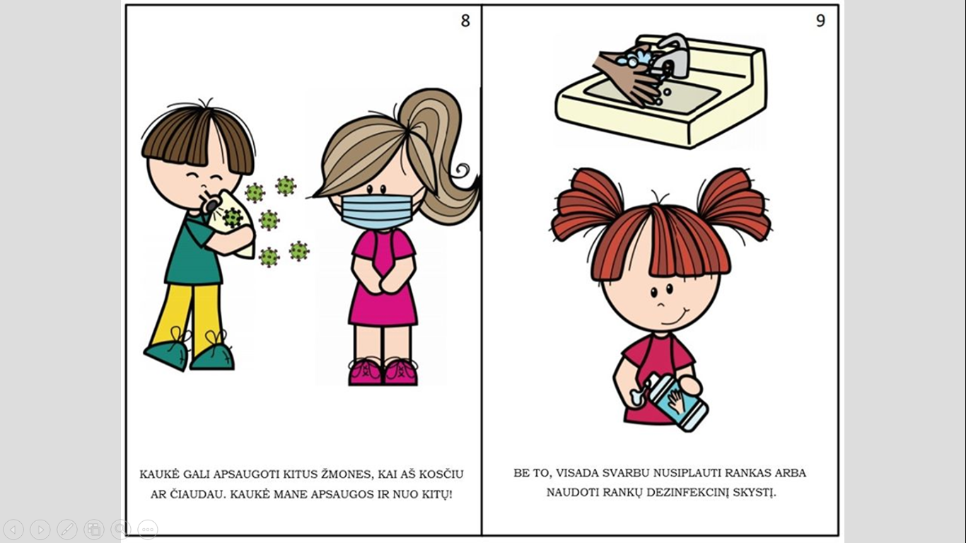

Teachers are proud and happy about huge feedback form their children. By encouraging, complimenting and thanking each other for close partnership, we receive huge feedback from parents and all community as well.
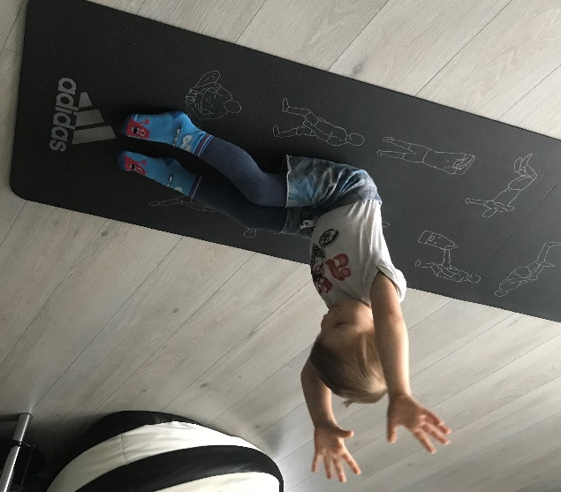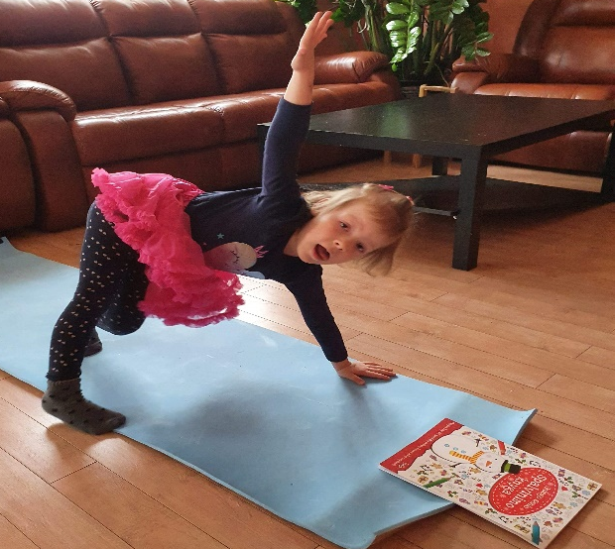

Teacher’s stressful circumstances and copping with it during remote education
Teacher is used to work and be surrounded by children all day long in nursery school. Edutacional process, sleeping time, games – teacher always with his children. But during quarantine period all vanished. Succesfully, teachers quickly reorganized their programs and settled in virtual space (everyobe choosed most convenient communication with children and thei parents tools). Anyway its not the same. Teachers in quarantine period more time spend in virtual spac, as well as communicating with children, parents, searching and researching for attractive educatiobal materials suitable for their kids and also thinking how all of this present for them, thats tasks must educate, but not put big load on parents. So it means stress is permanent in eeryday life. Means it must be measured how to behave to control spreading anxiety between educators. Thats why our community shares ideas how to cope to avoid and lessen stress during this complicated period:
- First of all and most important – make clear boundary between work and family things. All educators have their own families, which also need attention, thats why teacher and his family members must asknowladge where and when remote eduations ends. So parents should be informed about these hours;
- Communication with child and his parents, encouragement and compliment. We noticed that while encouraging parents give us better feedback, same we feel encouraged and quit;
- Close partnership with colleagues from the same nursery school, also from other schools. Communicating we may share by educating tools and means, ideas, and save our time for own families;
- Try spend more remote time with friends, family members: the need of communication not disappear, so its important suppress this need and make time for everyday communication with the loved ones;
- Work and rest regimen – teachers must have time for his hobbies and activities for rest and relax.
Those are simple and already known advices. But not less effective for coping with stressful situations and anxiety. We tried and used those advice, so it made anxiety, stress, and fair, mistrust less. Those advice become our success continuing our remote education, let us remain quiet and communicating.

Gargzdai nursery school teachers and public health specialist

